Cubesat EM Material Discharge Eval

Joshua Feldman

Michael Kim

Ian Poynter

Alejandro Torres

**Concept of Operations**

REVISION – Draft

9/14/2023

Concept of Operations

for

Cubesat EM Material Discharge Eval

Team 44

Approved by:

_____________________________

Project Leader Date

_____________________________

Prof. Kalafatis Date

_____________________________

T/A Date

**Change Record**

| **Rev.** | **Date** | **Originator** | **Approvals** | **Description** |
| --- | --- | --- | --- | --- |
| **-** | [9/14/2023] | [Ian Poynter] |  | Draft Release |
| 1 | [12/3/2023] | [Ian Poynter] |  | End of Semester Revision |

**Table of Contents**

**Table of Contents** **3**

**1.** **Executive Summary 4**

**2.** **Introduction 5**

2.1. Background 5

2.2. Overview 6

2.3. Referenced Documents and Standards 6

**3.** **Operating Concept 7**

3.1. Scope 7

3.2. Operational Description and Constraints 7

3.3. System Description 7

3.4. Modes of Operations 8

3.5. Users 8

3.6. Support 8

**4.** **Scenario(s) 9**

4.1. Orbiting Satellites 9

4.2. Deep Space Propulsion 9

**5.** **Analysis 10**

5.1. Summary of Proposed Improvements 10

5.2. Disadvantages and Limitations 10

5.3. Alternatives 10

5.4. Impact 10

# Executive Summary

As humanity continues to prioritize space travel, new technologies continue to be developed that help sustainable interplanetary travel become a reality. Ion thrusters are one such technology, creating thrust by accelerating ions with a high voltage. The ion thruster was first proposed in 1911 and first built successfully in 1959 at NASA, but current ion thrusters have low acceleration and require expensive Xenon as fuel. The Relativistic Ion Thrust Drive, or RIOT Drive, proposed by Orbital Arc plans to change that. The RIOT Drive will use a gentler ionization method than current Hall-Effect or gridded thrusters so cheaper and heavier fuel can be used, providing a much stronger propulsion and higher efficiency. For this project, we will design the chassis and essential systems of the first working prototype of the RIOT Drive, to produce a proof of concept that is functional enough to entice investors to sponsor a larger-scale project.

# Introduction

The Relativistic Ion Thrust Drive, or RIOT Drive, is an ion thruster that will ionize the fuel more gently than contemporary thrusters. This will allow the RIOT drive to use heavier fuel and accelerate the ions at a higher velocity providing about four times more efficiency than current ion thrusters. We will design the geometry, chassis, and software for a prototype of the RIOT Drive for Orbital Arc to improve in the future. Deliverables will include a CubeSat Standard compliant chassis, a functional power supply circuitry and microcontroller system for testing, and data collection coming from electrostatic potential testing on different accelerator plate shapes and insulating materials.

## Background

Ion thrusters are used for deep space travel in a variety of applications: from adjusting satellite orbits to propelling spacecraft throughout the solar system [1]. The most common types of ion thrusters are electrostatic or gridded, and electromagnetic or Hall-effect thrusters. Gridded Ion thrusters are more commonly used [2], and they operate by adding electrons to fuel to produce ions [1] and then accelerating the ions at a high velocity through electrically charged grids at the back of the thruster to produce thrust [2]. Most ion thrusters ionize by bombarding the atoms with high-energy electrons producing a positively charged ion [1]. The most common propellant used in ion thrusters is Xenon because it is easily ionized, it has high atomic mass, and it is a noble gas. These properties allow the ion thruster to have higher efficiency than less easily ionizable atoms, generate stronger thrust than other lighter ions, and remain stable during the ionization process. [1] [2].

The primary parts of an ion propulsion system include the ion thruster, the power processing unit, the propellant management system, and the digital control interface unit [1]. To power an ion thruster, electricity is provided by a spacecraft’s solar panels, [2] then the power processing unit, or PPU, converts the electricity into the voltages needed to accelerate the ions [1].

Orbital Arc was founded in February 2023 from the idea of the Relativistic Ion Thrust Drive or RIOT Drive. The RIOT drive is based on a linear particle accelerator and ionization without bombardment. With a linear particle accelerator, the exhaust velocity will reach several percent of the speed of light and exhibit relativistic mass expansion. These factors will increase the efficiency of the RIOT Drive over contemporary ion thrusters by about 4 times [3]. The second component of the RIOT Drive is the method of ionization. The current bombardment method of ionization will break molecular bonds, so an atomic fuel like Xenon must be used. The ionization of the RIOT Drive will use field effect ionization to generate ions cold and accelerate them without containment. This eliminates the problems of bombardment and allows a heavier fuel such as Sulfur Hexafluoride to be used [3].

## Overview

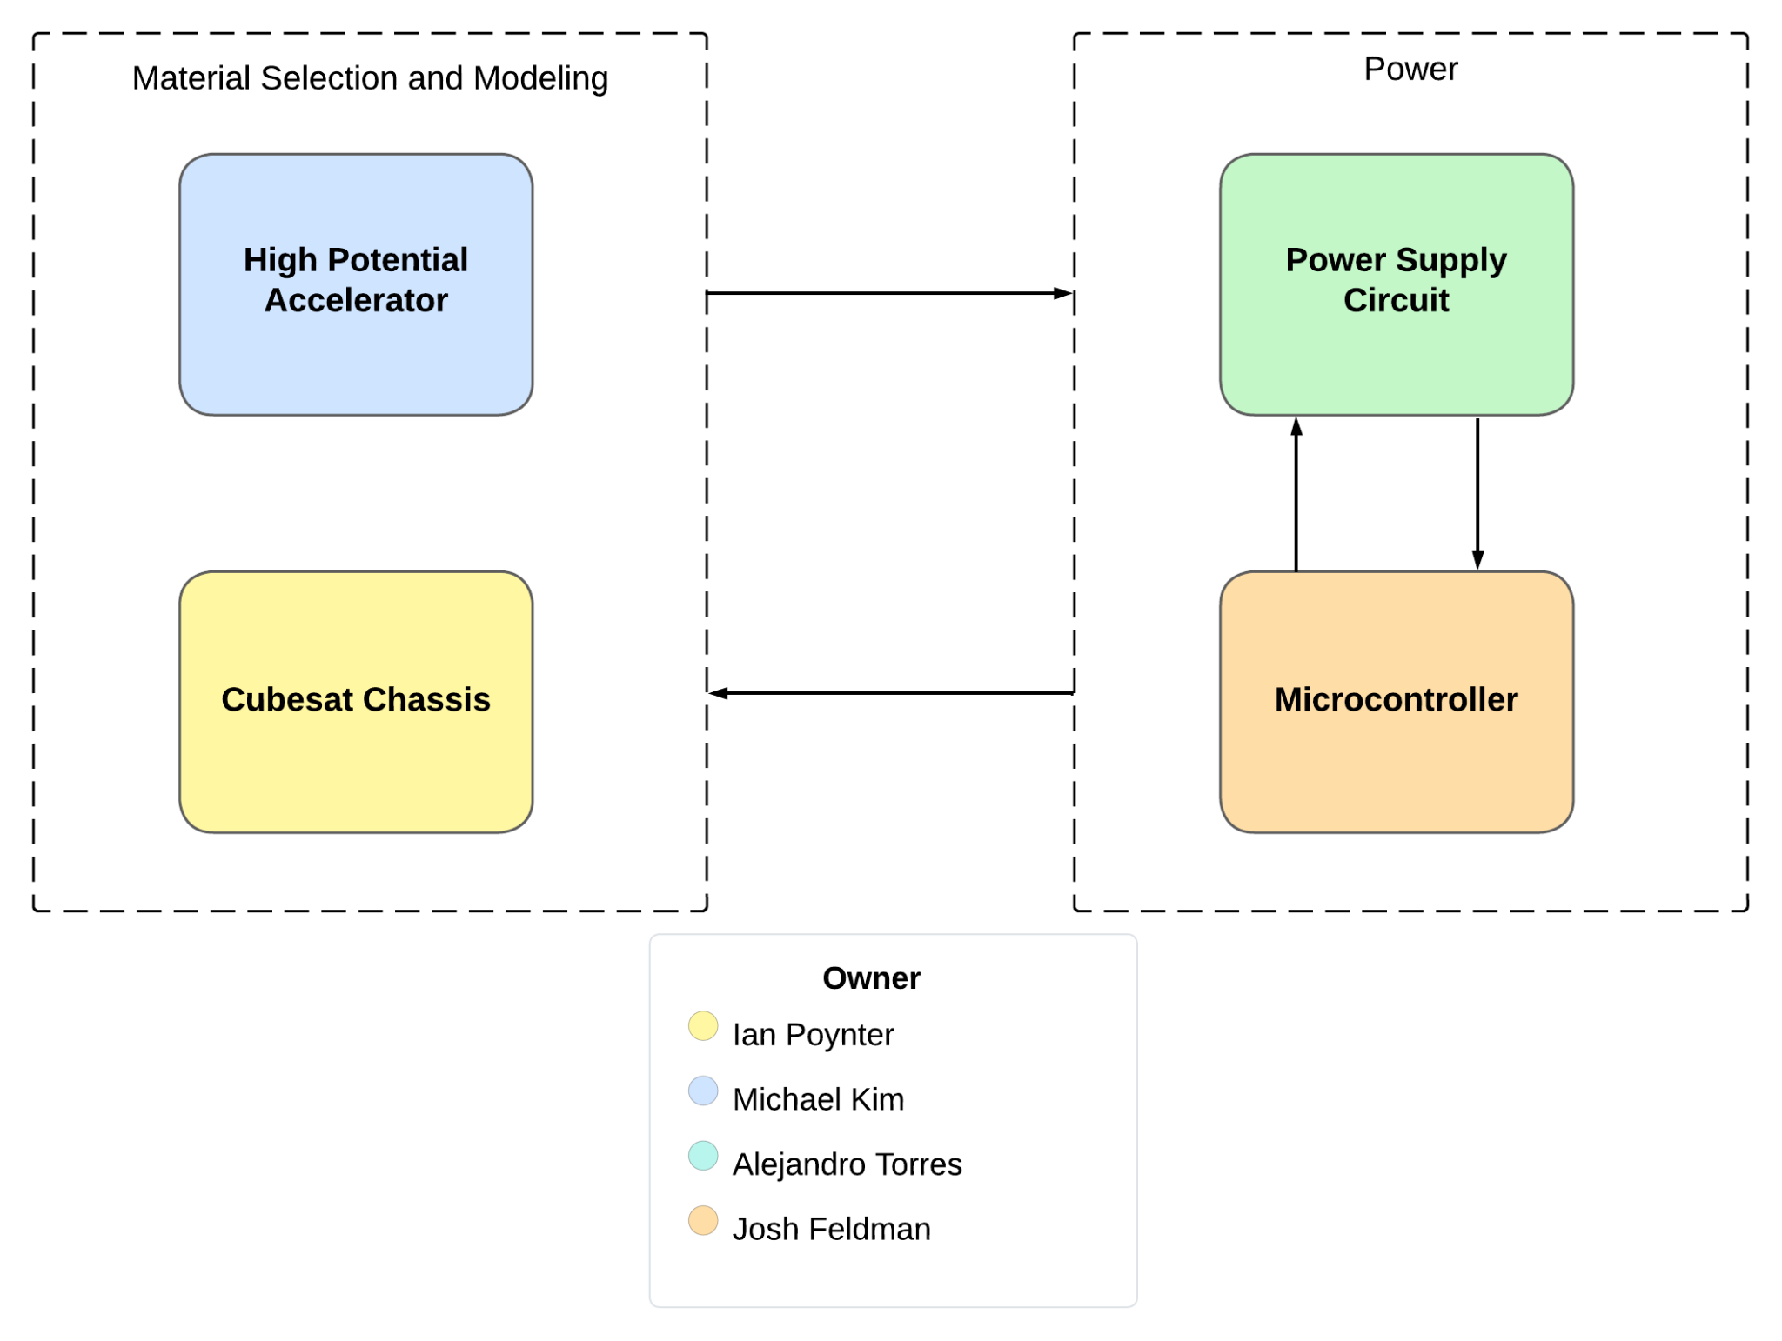

The RIOT Drive is a type of electrostatic ion thruster designed for deep space travel and has the design capabilities that reduce its reliance on delta-v compared to current ion thrusters. The primary limiting factor on the application of the thrust will be the power system that the ion thruster employs. The system will be tested with three different materials and three different geometries, totaling 9 different prototypes to be modeled. The system will also implement a circuit design that will fit within one unit of a CubeSat and will adhere to the required design specifications to power the thruster.

## Referenced Documents and Standards

1. Dunbar, Brian. “Ion Propulsion.” *NASA*, NASA, 18 Aug. 2015, [www.nasa.gov/centers/glenn/about/fs21grc.html](http://www.nasa.gov/centers/glenn/about/fs21grc.html).
2. Wessels, Wessel. “Ion Thrusters - What They Are and How They Work.” *Headed For Space*, 30 Jan. 2023, headedforspace.com/ion-thrusters-and-ion-propulsion/
3. *Orbital Arc*, 16 Aug. 2023, orbitalarc.com/.

# Operating Concept

## Scope

The RIOT drive prototype will fit on a CubeSat and propel it into outer space using Sulfur Hexafluoride as fuel. The Sulfur Hexafluoride will be ionized by nanotechnology designed by Orbital Arc and accelerated by a high-voltage plate to provide thrust. The fuel will then be neutralized by electrons to prevent a positive charge buildup behind the thruster that reduces efficiency. This will make the thruster an efficient method of propulsion for space travel, and can potentially revolutionize deep space propulsion in the future. For our prototype, we will establish a power supply with the ability to reliably deliver the necessary power to all required components on board while operating in a space environment. Additionally, experimental data will be collected on different accelerator plate geometries and materials, as well as different shielding techniques.

## Operational Description and Constraints

This project will be designed to function in the following conditions:

* Conditions of outer space, being a near vacuum environment and near absolute zero temperatures.
* The electronics need to be properly shielded from the normal operating voltage of 10kV and potential surges up to 100kV from the accelerator.
* The fuel supply needs to be precisely regulated over a large range of pressures.
* The solar panels that power the thruster need to receive enough sunlight as the CubeSat moves further from the sun.
* Many of the parts will be supplied by Orbital Arc, and will not be available for the demonstrations.

## System Description

* Accelerator: A gridded accelerator allows ions to accelerate at high speed. It also uses relativistic mass expansion to vastly increase the effective mass of fuel flowing out of the thruster. Responsibilities include material and geometry selection, data collection, and construction of a final plate to integrate with the CubeSat
* Power Network: Responsible for delivering correct voltage and amperage to multiple components, including the high voltage accelerator plates, thermionic cathode, ionizer chips, gas feed control valves, etc. Will need to fit inside one CubeSat unit and be capable of regular function in a space environment.
* CubeSat Chassis and Modeling: Responsible for procurement and construction of the CubeSat prototype, as well as taking responsibility for design parameters around safety and ability to operate in space. Thermal considerations will need to be taken to keep the ambient temperature in the system at a temperature where all components can operate. Calculations will be done to ensure compliance with NASA’s outgassing and radiation standards where possible.
* Microcontroller: Where a fully functional RIOT Drive would utilize the on-board electronics of the spacecraft, our prototype will implement a microcontroller to control the electronics of the system. The microcontroller will be able to activate the pulse charger, thermionic cathode, and ionizer chip as needed. The microcontroller will be located on the same PCB as the power supply.

## Modes of Operations

The RIOT drive will operate in normal propulsion mode and directional mode. Normal propulsion mode will accelerate the ions directly away from the CubeSat to propel it forward. The directional mode will induce a variable voltage on the plates to accelerate the ions at an angle. This can turn the CubeSat for any course corrections that are needed.

## Users

The RIOT Drive prototype will be designed for use by Orbital Arc to provide them with testing data for future designs. The RIOT Drive has the potential to revolutionize space travel in the future and in the future will be an improvement over current ion thrusters in space missions for NASA, ESA, or any space exploration company.

## Support

The users will be provided with support through instruction documents from Orbital Arc and meetings with Orbital Arc and the consumer company to discuss how the RIOT Drive will be used. For our prototype, thorough documentation of the design and operation will be provided through our FSR and ICD documents.

# Scenario(s)

## Orbiting Satellites

Ion thrusters play a pivotal role in the operation of orbiting satellites, from maintaining the orbit of China’s Tiangong Space Station to performing maneuvers for the SpaceX Starlink satellites. The efficiency of ion thrusters allows them to maneuver satellites in orbit with small amounts of fuel, allowing the satellites to operate for longer with a limited fuel source. Ion thrusters have great functionality in satellites, from small adjustments to deorbiting, and the RIOT Drive has the potential to accomplish these tasks more efficiently and cheaply.

## Deep Space Propulsion

Ion thrusters are crucial propulsion systems for deep space missions. Although ion thrusters accelerate gradually, they offer unparalleled efficiency and longevity compared to traditional fuel-based propulsion. Ion thrusters have been instrumental in missions like NASA’s Dawn or the ESA’s BepiColombo, which are exploring the asteroid belt and Mercury, respectively. An ion thruster’s low fuel consumption and ability to operate over extended periods make them the best choice for enabling intricate trajectories and exploration beyond the Earth’s orbit. The superior fuel efficiency and cost of the RIOT Drive compared to contemporary ion thrusters will progress advanced deep space exploration.

# Analysis

## Summary of Proposed Improvements

Our project will produce the first working prototype for the RIOT Drive, and will include tasks such as:

* Electrostatic accelerator which can accumulate up to 100kV of potential on surface
* Shielding from the electric field to protect internal electronics
* Internal circuit board to supply power to all system components
* Material, geometry, and component selection for all systems
* Capability to withstand physical stresses of space launch

## Disadvantages and Limitations

Potential limitations of the RIOT Drive project include:

* Many unknowns in performance as an emerging technology
* Inability to generate enough thrust to achieve liftoff on its own
* Limited ability to fully test prototypes due to no access to the ionizer chips
* Limitations in testing many components in vacuum conditions
* Many considerations for space readiness can not be tested, only modeled
* Small model may perform differently than full-size product

## Alternatives

As space travel currently exists, there are many alternatives to the RIOT Drive. These include:

* Traditional fuel propulsion
  + Able to achieve liftoff and exit Earth’s gravity independently
  + Already a proven method
  + Significantly less fuel efficient and a much heavier fuel
  + Takes up significantly more aircraft space
* Current Ion Thrusters
  + Generally considered ineffective for spacecraft, except for long-term control or small adjustments
  + Uses a less efficient and much more expensive fuel, Xenon
  + Currently used for station-keeping

## Impact

While ion thrusters are currently not viable for much more than slight adjustments in space, a working RIOT Drive will change that. Very few propulsion systems can compete with the delta-V that the RIOT Drive will provide, and it will become the preferred propulsion method for deep space missions. The significant reduction in fuel costs will make it more feasible to implement on satellites in ways that were too expensive or inefficient before. While this prototype will fit in a CubeSat, future systems will be larger, capable of creating enough thrust to be the main propulsion device of a large rocket or satellite once it reaches space. The RIOT Drive will allow us to send satellites further into space because of its high efficiency and speed, potentially leading to significant discoveries.